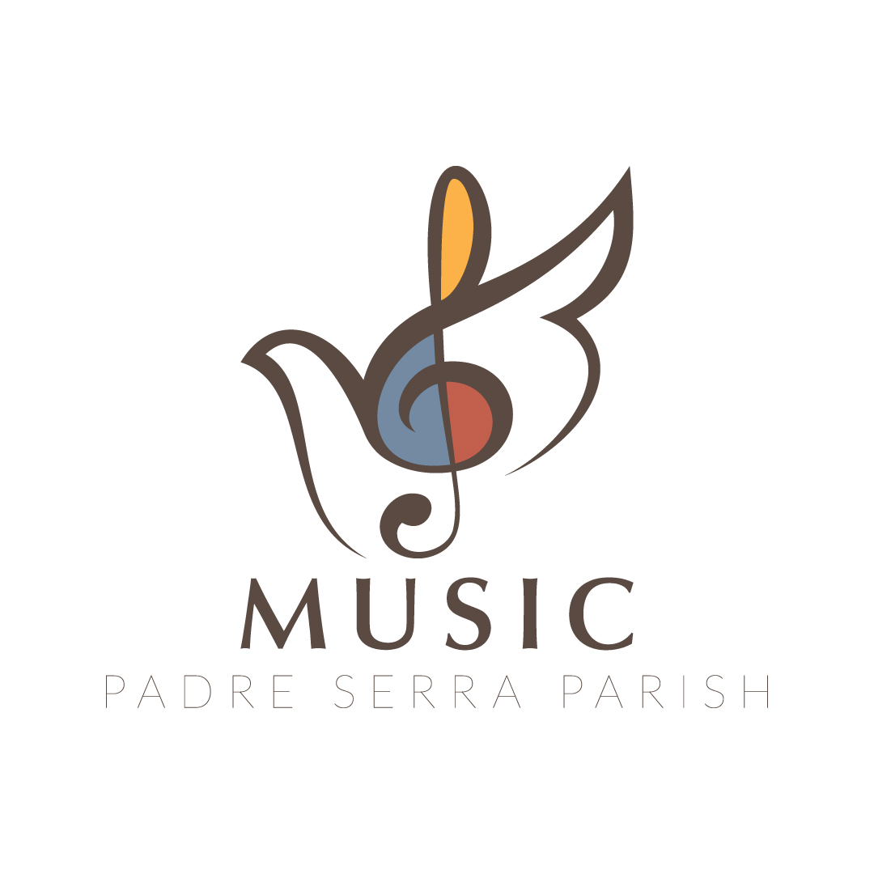

PSP Cherubs Music Program Registration Form Spring 2024

1st Child’s Name: ____________________________ DOB: ______________ Grade: ______

2nd Child’s Name: ____________________________ DOB: ______________ Grade: _____

3rd Child’s Name: ____________________________ DOB: ______________ Grade: _____

For any child in K, please circle preferred section (PS-K @9:30 OR K – 2nd grade @10:30)

Address: _________________________________ City: _______________ Zip:_________

Mother/Guardian: ___________________________________Phone:(c) ________________

Email:________________________________________ Virtus? Y/N___; Date__________

Additional phone or email: ____________________________________________________

Father/Guardian: _________________________________Phone:(c) __________________

Email:________________________________________ Virtus? Y/N___; Date__________

Additional phone or email: ____________________________________________________

PLEASE CIRCLE BEST EMAIL and BEST PHONE # ABOVE

Person(s), other than parent, that child can be released to: _____________________________

_________________________________________________________________________

Emergency Contacts (in case parents/guardians cannot be reached):

Name: ______________________ Relationship: ___________Phone #: _______________

Name: ______________________ Relationship: ___________Phone #: _______________

Allergies, sensitivities, medical/mental health issues or other info we need to be aware of: _________________________________________________________________________

_________________________________________________________________________
- I give Padre Serra Music Ministry Leaders permission to seek emergency medical assistance for my child if a parent cannot be reached.

Signature(s):__________________________________________ Date: _______________

Physician: _________________________________________ Phone:___________________

My child has permission to participate in Cherubs Music Ministry. I understand that photos or videos may be taken by the ministry leaders, and they may be used on the church website or literature.

Signature(s): ________________________________________ Date: __________________

